**In this video, we will discuss**  
**1.** What are T4 templates and their purpose  
**2.** Customizing T4 templates

**What are T4 templates and their purpose?**  
**T4** stands for **Text Template Transformation Toolkit** and are used by visual studio to generate code when you add a view or a controller.  
  
**Where does these T4 templates live?**  
C:\Program Files (x86)\Microsoft Visual Studio 10.0\Common7\IDE\ItemTemplates\[CSharp | FSharp | VisualBasic]\Web\[MVC 2 | MVC 3 | MVC 4]\CodeTemplates

**What is the file extension for T4 templates?**  
.tt  
  
**Is it possible to customize T4 templates?**  
Yes, T4 templates can be customized in place, if you want the customized T4 templates available for all MVC projects on that machine.  
  
If you want to customize T4 templates, only for a specific project, then copy **"CodeTemplates"**folder and paste it in the root directory of your MVC project. Right click on the template files(with .tt extension), and select Properties and delete **"TextTemplatingFileGenerator"**.    
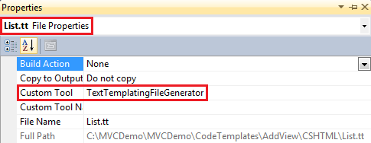   
  
By deleting this from **CustomTool**property, we are telling visual studio not to run them during the build. They will be manually called when we add a view or a controller using **"Add View"** and **"Add Controller"** dialog box.  
  
**Is it possible to add your own T4 template to the existing list of templates?**  
Absolutely, simply create a file with **".tt"** file extension in **"AddController"** folder in **"CodeTemplates"**. If it is for adding a view, then put it in **"AspxCSharp"**(if view engine is aspx) or **"CSHTML"**(if view engine is razor) folder.